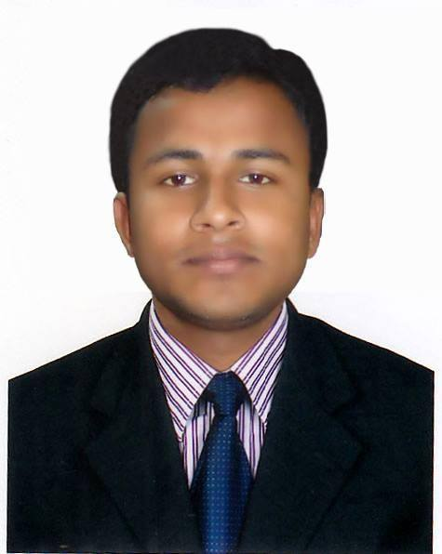
CURRICULAM VITAE
OF
MD. NAZMUL KAHAF

1. Name : Md. Nazmul Kahaf
2. Father’s Name : Md. Sheikh Saddi
3. Mother’s Name : Rahima Begum
4. Permanent Address : Vill: Shukhdhan, P.O: Ramgonj
P.S: Nilphamari, Dist: Nilphamari.
5. Present Address : Vill: Shukhdhan, P.O: Ramgonj
P.S: Nilphamari, Dist: Nilphamari.
6. Mobile : 01722-092843.
7. Date of Birth : 8th August 1991
8. Religion : Islam.
9. Nationality : Bangladeshi (by birth).
10. Marital Status : Unmarried.
11. Sex : Male.
12. Educational Qualification :

Examination | Year | Group/Sub | GPA/Division | Board/ University
B.A (Honors) | 2012 | English | 2nd Class | National University
H.S.C | 2008 | Humanities | 4.70 | Rajshahi
S.S.C | 2006 | Humanities | 4.69 | Rajshahi

Md. Nazmul Kahaf

